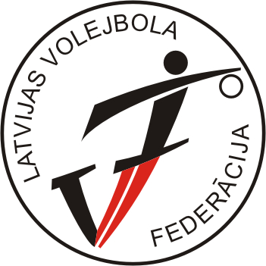
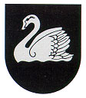
‘’BALTIC CUP – 2008 ‘’
Gulbene, LATVIA
24.-26.10.2008

A gr. girls (born 1992. / „+” )

TOURNAMENT TABLE

No | TEAM | 1 | 2 | 3 | 4 | POINTS | PLACE
1 | LATVIA I |  | . 2 .  3-2 | . 2 .  3-2 | . 2 .  3-0 | 6 | 1
2 | LATVIA II | . 1 .  2-3 |  | . 1 .  1-3 | . 1 .  0-3 | 3 | 4
3 | ESTONIA | . 1 .  2-3 | . 2 .  3-1 |  | . 2 .  3-0 | 5 | 2
4 | LITHUANIA | . 1 .  0-3 | . 2 .  3-0 | . 1 .  0-3 |  | 4 | 3

CALENDAR/RESULTS
Match no. | Date | Time | Hall | Team A | Team B | Results
BC-03 | 24.10.08 | 14:30 | Gulbenes SC | EST | LTU | 3-0 (22;16;19)
BC-05 | 24.10.08 | 17:30 | Gulbenes SC | LAT I | LAT II | 3-2 (12;-15;23;-18;13)
BC-09 | 25.10.08 | 12:00 | Gulbenes SC | EST | LAT II | 3-1 (18;-22;16;19)
BC-11 | 25.10.08 | 13:30 | Gulbenes SC | LAT I | LTU | 3-0 (21; 19; 23)
BC-17 | 26.10.08 | 10:00 | Gulbenes SC | LAT II | LTU | 0-3 (-23;-24;-16)
BC-19 | 26.10.08 | 11:30 | Gulbenes SC | LAT I | EST | 3-2 (-20;-22;14;26;12)

