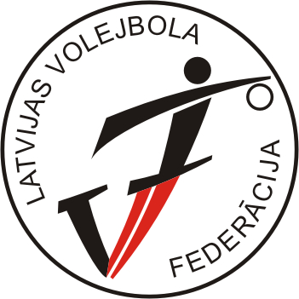
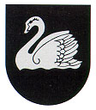
‘’BALTIC CUP – 2008 ‘’
Gulbene, LATVIA
24.-26.10.2008

A gr. boys (born 1991. / ”+” )

TOURNAMENT TABLE

No | TEAM | 1 | 2 | 3 | 4 | POINTS | PLACE
1 | LATVIA I |  | . 2 .  3-2 | . 1 .  1-3 | . 1 .  1-3 | 4 | III
2 | LATVIA II | . 1 .  2-3 |  | . 1 .  0-3 | . 1 .  0-3 | 3 | 4
3 | ESTONIA | . 2 .  3-1 | . 2 .  3-0 |  | . 2 .  3-2 | 6 | I
4 | LITHUANIA | . 2 .  3-1 | . 2 .  3-0 | . 1 .  2-3 |  | 5 | II

CALENDAR/RESULTS
Match no. | Date | Time | Hall | Team A | Team B | Results
BC-01 | 24.10.08 | 13:00 | Gulbenes SC | LAT I | LAT II | 3-2 (-20;23;-24;12;8)
BC-07 | 24.10.08 | 19:00 | Gulbenes SC | EST | LTU | 3-2 (21; 19; -34; -18;10)
BC-13 | 25.10.08 | 15:30 | Gulbenes SC | EST | LAT II | 3-0 (19;18;22)
BC-15 | 25.10.08 | 17:00 | Gulbenes SC | LAT I | LTU | 1-3 (-21;18;-24;-15)
BC-21 | 26.10.08 | 13:00 | Gulbenes SC | LAT II | LTU | 0-3 (-18;-21;-20)
BC-23 | 26.10.08 | 14:30 | Gulbenes SC | LAT I | EST | 1-3 (25:21; 18:25; 23:25; 20:25)

