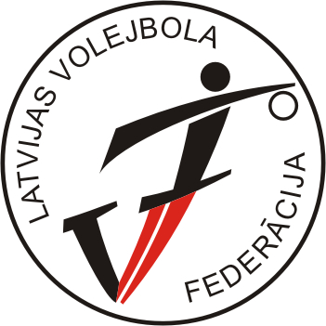

‘’BALTIC CUP – 2008 ‘’
Gulbene, LATVIA
24.-26.10.2008

B gr. boys ( born 1993. / „+” )

TOURNAMENT TABLE

No | TEAM | 1 | 2 | 3 | 4 | POINTS | PLACE
1 | LATVIA I |  | . 2 .  3-0 | . 2 .  3-0 | . 1 .  2-3 | 5 | 1
2 | LATVIA II | . 1 .  0-3 |  | . 1 .  0-3 | . 1 .  1-3 | 3 | 4
3 | ESTONIA | . 1 .  0-3 | . 2 .  3-0 |  | . 2 .  3-1 | 5 | 2
4 | LITHUANIA | . 2 .  3-2 | . 2 .  3-1 | . 1 .  1-3 |  | 5 | 3

CALENDAR/RESULTS
Match no. | Date | Time | Hall | Team A | Team B | Results
BC-06 | 24.10.08 | 17:30 | Gulbenes sp.school | LAT I | LAT II | 3-0 (10;16;13)
BC-08 | 24.10.08 | 19:00 | Gulbenes sp.school | EST | LTU | 3-1 (20;21;-16;13)
BC-14 | 25.10.08 | 15:30 | Gulbenes sp.school | EST | LAT II | 3-0 (17;17;19)
BC-16 | 25.10.08 | 17:00 | Gulbenes sp.school | LAT I | LTU | 2-3 (29;-22;18;-18;-13)
BC-22 | 26.10.08 | 13:00 | Gulbenes sp.school | LAT II | LTU | 1-3 (-18;-11;22;-17)
BC-24 | 26.10.08 | 14:30 | Gulbenes sp.school | LAT I | EST | 3-0 (23;22;19)

